Throughout the semester, we will use an application called “Zoom.”

Zoom Technical Support

To log on, follow these steps:

Step 1: Click on the Zoom Meeting URL.

Step 2: You will be taken to a page that looks like this:

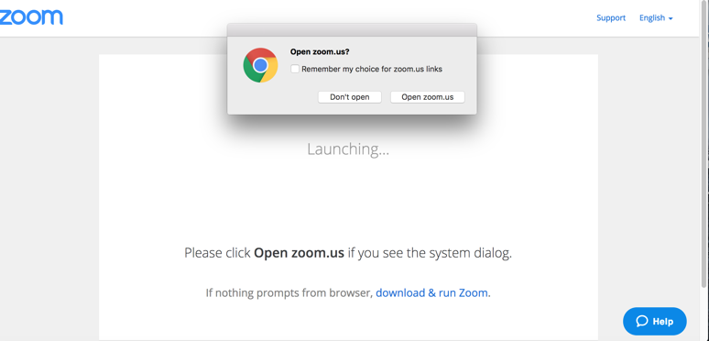
If the dialogue box does not appear, then click “download & run Zoom.” This will ask you to download a Zoom Launcher, which shouldn’t take more than a few moments.

Step 3: Once the “open.zoom.us” dialogue box does appears, click Open Zoom. If you are using Firefox, that box might look more like this:

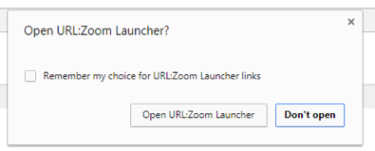

Step 4: You will be taken to the Zoom room, and prompted to select your audio & video options by a dialogue box that looks like this:

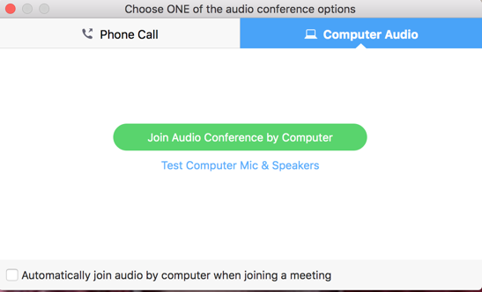

Most likely, you will just click “join audio conference by computer” and enter the room.

Step 5: Once you are in the room, if you hover your cursor near the bottom of the screen, you will see the Zoom menu (see next page):
↟(a) ↟(b) ↟(c) ↟(d) ↟(e)

- Clicking on “mute” or “stop video” will control your microphone and video feed. Clicking the arrows next to the microphone or video icons will allow you to troubleshoot audio/video difficulties.
- Clicking on “share screen” will allow you to show me your desktop (you can only do this when other participants are not also sharing their screens).
- Clicking on “chat” will allow you to open up the text chat box.
- Clicking on “breakout rooms” will let you go to your assigned small group room. We will always start our video chats as a full group and then I will send you to your breakout rooms to talk with your research teams.
- Clicking “leave meeting” will let you exit the room.

Please use headphones—this will help us avoid audio feedback.

Here are some videos to also show you how to access zoom and share your screens.
Here is a video showing you how to join a meeting https://youtu.be/vFhAEoCF7jg
Here is a video to showing how to share their screen https://youtu.be/9wsWpnqE6Hw.

